Text Area: | 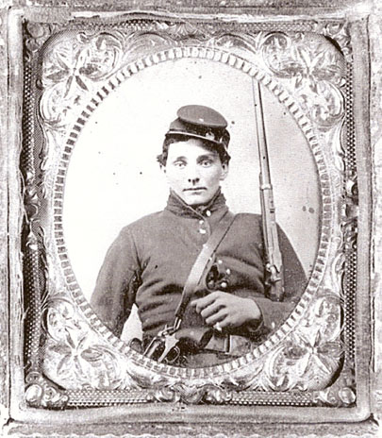  Union Private in Uniform  Text Area:

