Text Area: | 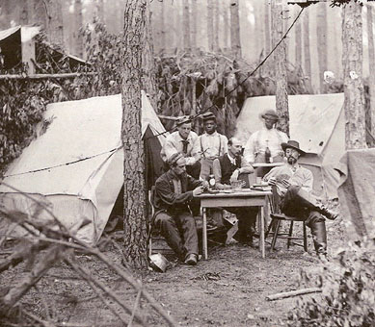  Soldiers Sharing Time Together  Text Area:

