Text Area: | 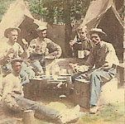  Soldiers Sharing Meal Together  Text Area:

