Text Area: | 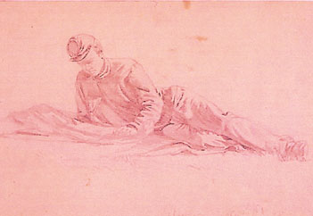  Soldier Reading the Newspaper  Text Area:

