Text Area: | 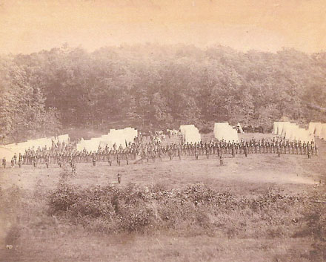  Union Troops in Formation  Gettysburg  Text Area:

