Text Area: | 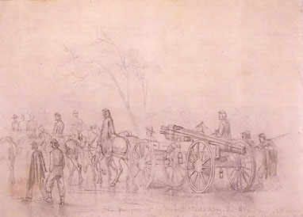  Union Pursuing Lee after  Gettysburg  Text Area:

