Text Area: | 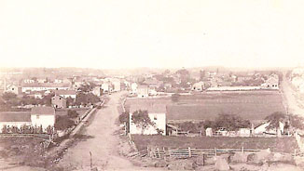  North Side Gettysburg approx. 1863  Text Area:

