Text Area: | 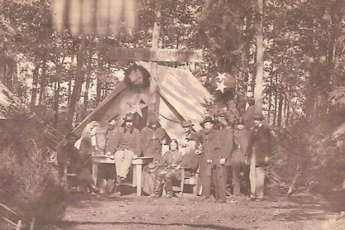  Convalescent Encampment  Gettysburg  Text Area:

