Text Area: | 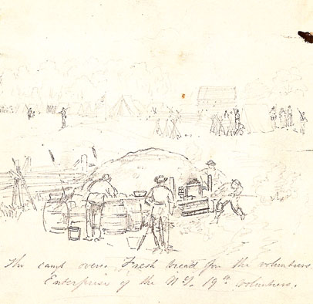  Making Fresh Bread in Union Army  Text Area:

