Text Area: | 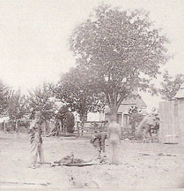  Ambulance Support Team  Retrieving Wounded  Text Area:

