Text Area: | 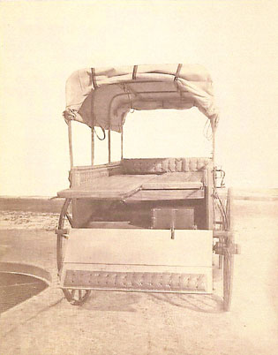  Civil War Ambulance – Rear View  Text Area:

