Data Guide for Gathering Information
About
Albert S. Green

Directions: Fill in the blanks with information taken from Saratoga Manufacturing Ledgers. If other ledger data appears important to your story, add to notes on second page.
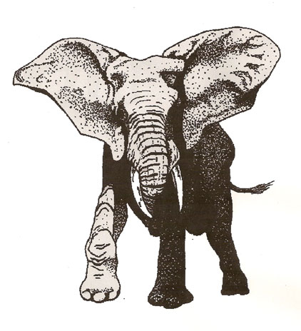

Saratoga Manufacturing Ledgers:
Albert S. Green worked at _____________________________, a textile company located in Victory Mills, New York, in the years preceding his military service. Although Albert Green’s Muster Record indicated that he was a carpenter, his role at the company is not identified in the ledgers. The accounts show that Albert purchased cords of _________________ from the company, possibly to heat his home (see accounts 6-28-1856, 8-28-1856, 9-27-1856, 10-25-1856, 12-27-1856). On July 1, 1856, Albert rented a ________ from Saratoga Manufacturing at the price of $ ___________ for six months. Four years later, as of July 2, 1860, the six month fee still remained at $ __________. In the summer months, Albert also rented a ____________ ( see accounts 7-01-1858, 7-1-1861) and a lot for _____________ (see account 7-26-1856). One summer month, Albert purchased a __________ (see account 6-28-1856). Whether the animal was for eating or breeding is not known. Other commodities besides wood and an occasional animal which Albert bought from his employer included ____________ (see account 2-26-1859), ____________ (see account 3-31-1860), ___________ (see accounts 10-27-1860, 11-24-1860), and ___________ (see account 11-30-1858).

Additional Notes:

