Data Guide for Gathering Information
About
Albert S. Green

Directions: Fill in the blanks with information about Albert S. Green taken from Private Alonzo Bump’s Civil War letters. If other data appears important to your story, add to notes on second page.
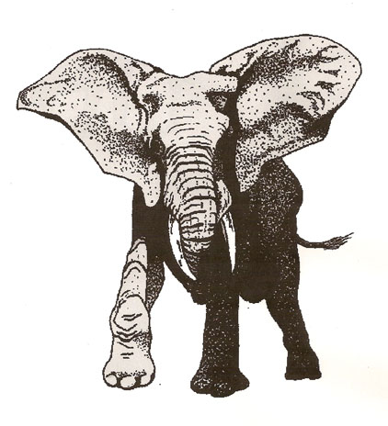
Alonzo Bump Letters:
According to the Civil War letters of Private Alonzo Bump, Albert S. Green joined the military and shared a tent in Albany Barracks in his month of training with two friends _____________ and __________ (see letter August 31, 1862). He also shared a tent with __________ in April 1863, as well as with two other men with similar last names ___________ and _________ (see letter April 12, 1863). The tent had a ___________ in one end and was, in the view of Alonzo Bump, the “_______ _______” in his company. ____________, the man with whom Albert shared a tent in Albany Barracks, died (see letter April 12, 1863). Albert wanted Ell, a friend, to take “_______ _______” of the man’s watch (see letter April 15, 1863). Albert Green’s camp diet varied, including ________ sometimes as often as four times per week (see letter March 4, 1863) and ___________ (see letter May 19, 1863).
Albert had a serious problem while in the military. He was reported as a ___________ and reduced to the ranks (see letter August 17, 1863). Alonzo felt the reduction unjust because he was with Albert at the time that he “_________ _______ ________ _________” due to illness (see letter July 16, 1863). Alonzo’s letters also indicate that in August, 1863, Albert was detailed to the __________ in Gettysburg to take care of the wounded. Alonzo also mention that in November, 1863, Albert went _____________.
Additional Notes:

