Data Guide for Gathering Information
About
Albert S. Green

Directions: Fill in the blanks with information taken from Albert S. Green’s Muster Record. If other Muster Record data appears important to your story, add to notes on second page.

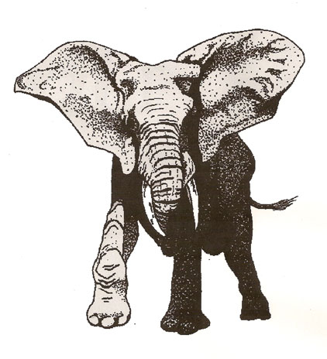

From the Muster Record:

Albert S. Green was born in the town of ______ and state of ____ in the year ____.
Note: To determine the year of birth:
Subtract Albert’s age from the year of his military enrollment.
As an example:
If Albert enrolled in the military in 1850 and he was 30
at the time of enlistment, then 1850 – 30 = 1820.

At the age of __________, Albert had __________ eye color, _________ hair color, and was _______ foot _______ inches in height. Before entering the military, Albert worked as a _____________. He enrolled in the military in the town of __________ in the month of __________ and year _______ . After about _________ month(s) training, Albert was mustered into service in the month of ________ and year _______ in company _______ of the ________ regiment. His military branch was the ___________ and military level or grade was _________. Albert remained in the service through the year of __________. His record shows that he was demoted from ______________ to ____________ in the year of ________ for the reason of _______________________ (if no reason is given on the record, state this). He was detached to _______________________ shortly after his demotion (look at bottom of muster record page one).
Additional Notes:

